C/C++ RESERVATION SYSTEM LAB REPORT

1) Enter your name, student ID, platform (Mac or PC) and date
Name: Brian Quintero
Class: CIS054 C/C++ Programming
Platform (Mac or PC): Pc
Date: 5/2/17

DESCRIPTION:
Write a program that reserves seats for a theater, airline, etc. using a two-dimensional array. The program should start by asking for the number of rows and seats on each row and display the available seats. The rows are to be identified by a number starting at '1'. The seats on each row are to be identified by a letter, 'A', 'B', 'C', etc. For example, 3C, 4A and 2D are sample seat identifiers.

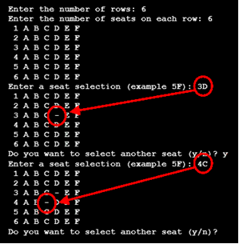
Because the total number of rows and seats is unknown when the program first starts, it will be necessary for the program to dynamically allocate memory for the seating array and then release that memory when the program is ready to end.

The program should ask the user to select row and seat. The program needs to verify and process only legal row and seat requests. If the seat is already reserved, the program should notify the user that the seat is taken. If the seat is available, the program should replace the seat identifier with a dash character '-'. The program should contain a loop to ask if additional seats are to be reserved. The program should also give a message when all the seats are taken. A counter can be used to keep track of the total number of seats purchased.

When running the program, you must use a minimum
of 3 rows and 4 seats. The program output part of the
lab report must show these minimums. The program output must also show a sample display of when more than one seat is taken, and another display showing a message when all seats are taken.

LAB REPORT:
2) Fill in the HIPO chart using English or pseudo-code. Do NOT paste your program or any part of it in the PROCESSING section.
INPUTS | PROCESSING | OUTPUTS
Number of Rows  Number of seats | do  {  cout << endl << "Enter a seat selection" << endl << " (example 5F -or- 00 to quit): ";  cin >> rowSelection; // get row from the user  cin >> seatSelection; // get the seat from the user  if (rowSelection == '0')  continue; // skip the rest of the loop  seatSelection = toupper(seatSelection); // convert to upper case  row = rowSelection - '1'; // count from zero to work with the array  seat = seatSelection - 'A'; // convert 'A' to 0, 'B' to 1, 'C' to 2, etc.  if (row < 0 ||row >= NumberOfRows)  {  cout << "Row number Invalid" << endl;  }  else if (seat < 0 || seat >= NumberOfSeats)  {  cout << "Seat number Invalid "<< endl;  }  else if (ArrayOfSeats[row][seat] == '-')  {  cout << "Seat is taken, we no longer overbook!"<< endl;  }  else  {  ArrayOfSeats[row][seat] = '-';  } | else  {  ArrayOfSeats[row][seat] = '-';  }  bool empty_seats = false;  for (int n = 0; n < NumberOfRows && !empty_seats; n++)  {  for (int v = 0; v < NumberOfSeats && !empty_seats; v++)  {  if (ArrayOfSeats[n][v] != '-')  {  empty_seats = true;  }  }  }  if (!empty_seats)  {  return 0;  }
DISCUSSION:
3) Complete the DISCUSSION section. It does not need to be long, but it needs to be complete.
3a) What did you do to develop the program? ("Followed the Directions" is not a complete description)

I had to figure out the if-else statement, I figured out how to make the code for invalid seat and row inputs as well as if all seats were taken. After I figured out what would happen if something invalid was put in I set the else statement to set a dash for a seat that was requested.

3b) What problems did you have and how did you overcome the problems?

I needed to figure out what the code that was given to me needed. As well as how to set up the code once I figured out what was finally needed. Tutor once a week is really putting me behind.

PROGRAM OUTPUT:
4) Show a screen shot for purchases of at least TWO seats and another screen shot with a message that shows what happens when ALL seats have been purchased..
Refer to previous lab assignments for instructions on how to capture a screen or portions of a screen for either the PC or a Mac

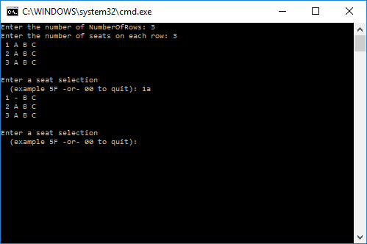
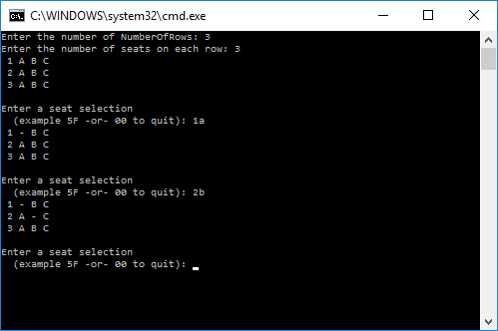
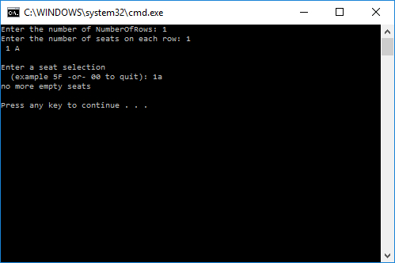

PROGRAM LISTING:
5) Copy and paste the code that YOU typed to make the program work. Your program should include a comment block at the top that shows the name of the program, date, version and your name.

//Brian Quintero
//Cis054 C/C++
//PC
//5/2/17

#include "stdafx.h" // only for several versions of Microsoft Visual Studio
#include <iostream>
#include <cctype>
using namespace std;

// Function declarations (prototypes)
char ** CreateArrayOfSeats(int NumberOfRows, int seats);
void InitializeSeats(char **ArrayOfSeats, int NumberOfRows, int seats);
void DisplayArrayOfSeats(char **ArrayOfSeats, int NumberOfRows, int seats);
void MemoryCleanup(char **ArrayOfSeats, int NumberOfRows, int seats);

int main(int argc, char* argv[])
{
char **ArrayOfSeats;
int NumberOfRows;
int NumberOfSeats;
char rowSelection; // 1 to max NumberOfRows, input from the user
char seatSelection; // 'A' to max seats, input from the user, convert to a number
int row; // index into ArrayOfSeats, 0 to NumberOfRows-1
int seat; // index into ArrayOfSeats, 0 to seats-1

// get the number of NumberOfRows and seats from the user
cout << "Enter the number of NumberOfRows: ";
cin >> NumberOfRows;
cout << "Enter the number of seats on each row: ";
cin >> NumberOfSeats;

ArrayOfSeats = CreateArrayOfSeats(NumberOfRows, NumberOfSeats);
InitializeSeats(ArrayOfSeats, NumberOfRows, NumberOfSeats);
DisplayArrayOfSeats(ArrayOfSeats, NumberOfRows, NumberOfSeats);

do
{

cout << endl << "Enter a seat selection" << endl << " (example 5F -or- 00 to quit): ";
cin >> rowSelection; // get row from the user
cin >> seatSelection; // get the seat from the user
if (rowSelection == '0')
continue; // skip the rest of the loop

seatSelection = toupper(seatSelection); // convert to upper case
row = rowSelection - '1'; // count from zero to work with the array
seat = seatSelection - 'A'; // convert 'A' to 0, 'B' to 1, 'C' to 2, etc.

if (row < 0 ||row >= NumberOfRows)
{
cout << "Row number Invalid" << endl;

}
else if (seat < 0 || seat >= NumberOfSeats)
{
cout << "Seat number Invalid "<< endl;

}
else if (ArrayOfSeats[row][seat] == '-')
{
cout << "Seat is taken, we no longer overbook!"<< endl;

}
else
{

ArrayOfSeats[row][seat] = '-';

}

bool empty_seats = false;
for (int n = 0; n < NumberOfRows && !empty_seats; n++)
{
for (int v = 0; v < NumberOfSeats && !empty_seats; v++)
{
if (ArrayOfSeats[n][v] != '-')
{
empty_seats = true;
}
}
}
if (!empty_seats)
{
return 0;
}

DisplayArrayOfSeats(ArrayOfSeats, NumberOfRows, NumberOfSeats);

} while (rowSelection != '0');

MemoryCleanup(ArrayOfSeats, NumberOfRows, NumberOfSeats); // return the memory that was allocated

cout << "Press the ENTER key to continue...";
char buff[100];
cin.getline(buff, 100);
return 0;
}

char **CreateArrayOfSeats(int NumberOfRows, int seats) // ** means pointer to pointers
{
char **ArrayOfSeats;
ArrayOfSeats = new char*[NumberOfRows]; // create an array of pointers for the NumberOfRows
for (int r = 0; r < NumberOfRows; r++)
ArrayOfSeats[r] = new char[seats]; // create an array of seats for each row
return ArrayOfSeats; // return pointer to the array back to the main program
}

void InitializeSeats(char **ArrayOfSeats, int NumberOfRows, int seats)
{
for (int r = 0; r<NumberOfRows; r++) // initialize the data for each row
{
for (int s = 0; s<seats; s++)
ArrayOfSeats[r][s] = 'A' + s; // put 'A' 'B' 'C' etc in each row
}
}

void DisplayArrayOfSeats(char **ArrayOfSeats, int NumberOfRows, int NumberOfSeats)
{
for (int r = 0; r<NumberOfRows; r++) // for each row
{
cout.width(2);
cout << r + 1 << ' '; // Display row numbers starting from 1
for (int s = 0; s<NumberOfSeats; s++)
cout << ArrayOfSeats[r][s] << ' '; // Display info for each seat
cout << endl; // new line after each row
}
}

void MemoryCleanup(char **ArrayOfSeats, int NumberOfRows, int NumberOfSeats)
{
for (int r = 0; r<NumberOfRows; r++)
delete[] ArrayOfSeats[r]; // delete each row of seats individually
delete[] ArrayOfSeats; // delete the row array
}

